NEW USER INTERFACE FEATURES:
New user interface features were added to make ASTRO for Windows easier to learn and easier to use.

Toolbar.
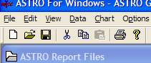
ASTRO for Windows has at the top left of its main window a toolbar. The left button (new file or blank document) starts a new chart using the new chart wizard described below. The File Open button uses the new file open dialog below. The save button exports a chart and the cut, copy, paste and print act as they do in other applications

File Open Dialog.

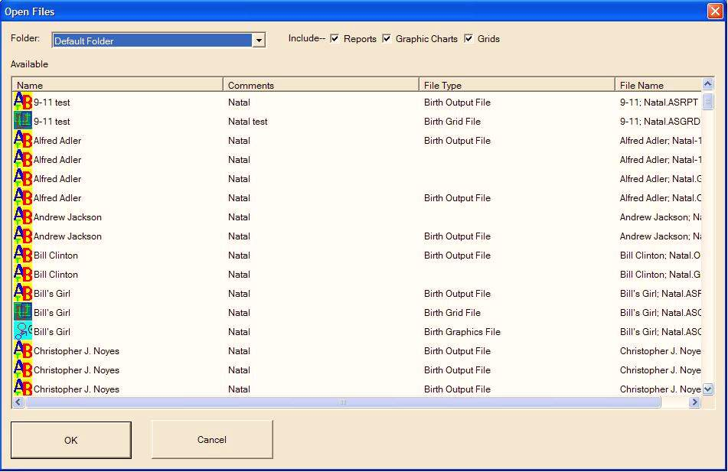

ASTRO for Windows has a new file open dialog that comes up with the file open button on the toolbar which will be easier to use than the traditional file management screens. This screen shows all the applicable files in your system of the applicable types. To open files, just click on the items in the left column and hit the OK button. If you want to select multiple files, hold down the control key and click on any that you want. You can sort the list by clicking on the column headers of the column you wish to have the files sorted by, for example to sort by comments, click on the comments header where it says Comments. If you have multiple folders setup, you can choose a folder to show. The checkboxes at the top allow you to filter by the type of file. If you wish to only Open reports, uncheck the grid and graphics files.

Chart Wizard.
ASTRO for windows has a new chart wizard, which can make it far easier for new users to compile new charts. Traditionally one had to go into the data menu and edit various data screens and then go to the compile menu and then open the charts to see them. This new wizard allows you to do all in one step. Choose the type of chart to do, enter person’s name and comments for the file list, and select a folder and hit the next button. The wizard will show all the necessary screens in sequence that you need to fill in and then compile the charts and opens them so you can view them. At the bottom of the screen are a set of buttons. If you can go back to a prior button, the back button will be enabled, if there is a next page that you need to go to you will see the next button enabled. When you are ready to compile your chart, the done button will be enabled. To compile the charts, hit the done button, to move forward and back use the Next and Back buttons

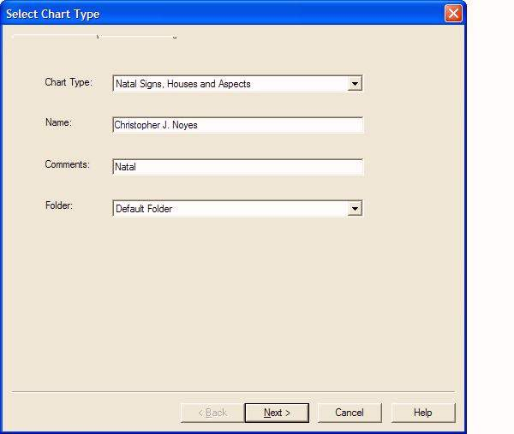

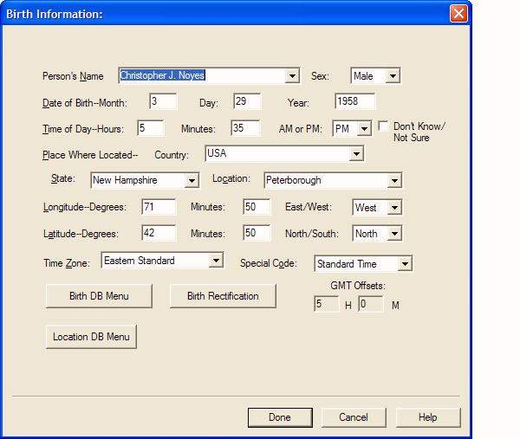

If you don’t know a person’s birth and don’t understand the ideas around Birth Rectification, you can just check the Don’t Know/Not sure checkbox and it will compile the chart with the default rectification for the chart type, which can be either Solar chart, or Ascendant equal to your sun, or Flat chart which makes the ascendant zero degrees Aries. You can configure this option in Options/Chart Options/(Your chart type) .

